**Jacobsen, Jens Peter (J.P.) (1847-1885)**

[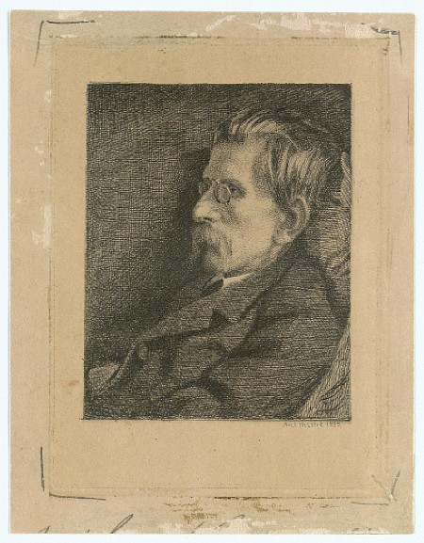](http://www.kb.dk/image_client_static/viewer_single/?src=online_master_arkiv_6/non-archival/Images/BILLED/2010/jan/kendis/ke006807.tif)

[Portrait of J. P. Jacobsen by Axel Helsted (1885): http://www.kb.dk/images/billed/2010/okt/billeder/subject2258/da/?&page=1]

Jens Peter Jacobsen was a Danish novelist, scientist, and poet whose texts combine close observations of nature with sensitive portrayals of human psychology. Although he was not a prolific writer, producing just two novels, one novella collection, and a book of poetry, Jacobsen’s works occupy a central place in the Danish literary canon because of their innovative combination of naturalist detail and evolutionary science. Drawing on his scientific training and conditioned by his atheism, Jacobsen depicts his human characters as governed by the same instinctive biological forces as animals, rather than moral or theological ideals. He employs a detailed, visual style and focuses on individual moments instead of providing a cohesive narrative. His female characters tend to be strong and erotic, while the men are introspective dreamers. Major works include the novels *Fru Marie Grubbe* (1876), the story of a noblewoman in eighteenth century Denmark who trades a royal castle for a ferryman’s hut to satisfy her sexual desires; *Niels Lyhne* (1880), which deals with the psychological challenges faced by a melancholy young atheist in nineteenth century Denmark; and the novella *Mogens* (1872), about a young man whose life is determined by heredity and milieu.

Born in Thisted on April 7, 1847, Jacobsen was an unlikely literary revolutionary. He studied botany at the University of Copenhagen and was influenced, by Ludwig Feuerbach, Ernst Häckel, and, especially, Charles Darwin. Jacobsen translated Darwin’s *The Origin of Species* and *The Descent of Man* into Danish in the 1870s and published articles about Darwinism in the left-leaning journal *Nyt dansk Maanedskrift,* where his first novella, *Mogens,* appeared in 1872*.* Dense with detailed descriptions of nature,Jacobsen’s texts explore connections between the animal world and the human psyche. Because of his atheistic views and scientific approach to literature, Jacobsen’s work was acclaimed as representative of the Modern Breakthrough, the movement toward socially critical realistic literature popularized by literary critic Georg Brandes. Jacobsen’s affiliation with Brandes was ambivalent at best, largely because Jacobsen was disinterested in politics. Instead of explicitly engaging with social issues, Jacobsen explored themes of longing, melancholy, and irony. Jacobsen did, however, maintain a close friendship and extensive correspondence with Brandes’s younger brother, Edvard, a playwright, politician, and co-founder of the liberal Danish newspaper *Politiken.* Diagnosed with tuberculosis in 1873, Jacobsen died in Thisted on April 30, 1885, at the age of 38. Despite their different stylistic priorities, Georg Brandes energetically promoted Jacobsen’s work in Germany and Austria, where it became popular in the 1890s, particularly among Symbolist poets such as Rainer Maria Rilke and Stefan George. Jacobsen’s work appeared in one hundred and thirty German-language editions from 1900 to 1965.

**Collected Works**

*Samlede Værker*. Ed. by Morten Borup. 5 vols. Copenhagen: Det Danske Sprog- og Litteraturselskab, 1924-29.

**List of Works**

*Fru Marie Grubbe: interieure fra det syttende aarhundrede* (1876)

*Niels Lyhne* (1880)

*Mogens og andre noveller* (1882)

*Digte og udkast* (1886)

**Translations**

Jacobsen, J.P. *Marie Grubbe. A Lady of the Seventeenth Century.* 1917.

Jacobsen, J.P. *Mogens and Other Tales.* Trans. by Tiina Nunally. Seattle: Fjord Press, 1994.

Jacobsen, J.P. *Niels Lyhne.* Trans. by Hanna Astrup Larsen. New York: The American-Scandinavian Foundation, 1919.

Jacobsen, J.P. *Poems and Sketches: bilingual edition.* Trans. by David W. Colbert. Ed. by Sven Haakon Rossel and Monika Wenusch. Vienna: Praesens, 2010.

**Internet Resources:**

Entry for Jacobsen on Forfatterweb: <http://www.forfatterweb.dk/forfatterweb/oversigt/jacobsen-j-p>

Entry for Jacobsen on Arkiv for Dansk Literatur:

http://adl.dk/adl_pub/forfatter/e_forfatter/e_forfatter.xsql?ff_id=6&nnoc=adl_pub